The role of background effort in split-belt adaptation

Methods
Subjects: Participants in the split-belt walking study (n = 45; 24W, 21M) with an average age of 24.5 ± 4.79 (mean ± standard deviation) years all signed a consent form approved by the Institutional Review Board at the University of Colorado Boulder. Participants were healthy and reported no known neurological or balance disorders and had no recent injuries affecting the lower limb. All participants were compensated for their time. Participants were evenly divided into randomly assigned effort conditions—high, low, and control—which were differentiated by the additional weight worn in a vest during the task. Three participants were excluded because they were unable to walk comfortably on the treadmill or unable to let go of the handrails during fast tied or split-belt blocks. Ultimately, the three groups (low, high, and control) consisted of 15 participants each. Of the participants in the low or high effort conditions, 22 returned for a second visit within 14 days to repeat the task in the opposite condition (11 participants high- low and 11 participants low – high, see figure 5c).
Experimental setup: All participants walked on a treadmill with a separate belt for each foot (Bertec Instrumented Treadmill). Participants wore a weighted vest which contained no additional weight (control condition), 5% of bodyweight (low effort condition), or 15 % of bodyweight (high effort condition). Weight was added to the vest weight in 1.13 kg (2.5 lbs.) increments, so percentage body weight was rounded down from 5% bodyweight in the low effort condition and rounded up from 15% bodyweight in the high effort condition. Participants were instructed to be prepared to grab on to handrails when the treadmill started or stopped but were asked to let go of the handrails within 5 seconds of the treadmill starting. This instruction was included because of previously observed differences in adaptation when grasping handrails (Buurke et al. 2019). Treadmill speeds were always 0.5 m/s (slow speed) or 1.5 m/s (fast speed) and accelerated from a stop at a rate of 0.5 m/s. During tied blocks, the two belts moved at the same speed. During split blocks, one belt was moving at the fast speed while the other was moving at the slow speed. Participants were randomly assigned a “fast leg,” right or left, and the assignments were kept even within groups. For participants who visited the lab twice and completed the task in high effort and low effort conditions, the order of conditions was counterbalanced.
Protocol: Participants completed seven walking blocks with short (less than 30 second) pauses between blocks. Participants were warned of stops or starts by a series of three beeps and instructed to prepare to grab the handrails if needed. The first block consisted of 1 minute walking with both belts at slow speed. This was included to help accustom participants to walking on the two separate belts. The second and third blocks were two minutes each tied at the fast and slow speed respectively to record baseline gait parameters during symmetrical walking. During the learning block, the split-belt perturbation (belt ratio 3:1 with speeds at 1.5 m/s and 0.5 m/s) was introduced and remained constant for 10 minutes while participants walked continuously. Following learning, adaptation was washed out during a 15-minute block of continuous walking at the slow speed. During relearning, the belt speeds split again for 10 minutes, keeping fast leg consistent with the first learning block. Participants finished the task with 2 minutes walking at the tied slow speed to ensure a safe return to overground walking. This protocol is illustrated in figure 5d.
Data Collection: During the entirety of the walking task, ground reaction forces and moments were collected via force plates embedded in the treadmill belts at a sampling rate of 1000Hz. Motion capture data based on a Plug-In Gait model with 16 reflective markers placed on the lower body was collected at 100 Hz (Vicon Vero Cameras; Vicon Nexus software). The Plug-In Gait Model, shown for one side of the body in figure 5b, includes markers on the right and left toe, heel, malleolus (ankle), knee, thigh, and anterior and posterior superior iliac crests (pelvis). Data was analyzed using custom MATLAB scripts.
Metrics: We will define a stride as the movement between a heel strike and the subsequent heel strike on the same foot. Stance is the movement while the foot is on the ground, starting with a heel strike and finishing with a toe off. Swing is the movement while the foot is in the air, after toe off and before the next heel strike. A step corresponds to the stance and swing for a single leg. Step length (SL) is calculated as the distance between the feet at the time of forward foot heel strike. Step time is the time between heel strikes on opposite feet.
The primary metric for learning in split-belt adaptation is step length asymmetry (SLA), defined as
 | $$SLA = \frac{{SL}_{fast} - {SL}_{slow}}{{SL}_{fast}+ {SL}_{slow}}.$$ | Equation 5
Step length asymmetry describes the ratio of step lengths between the leg on the fast belt and the leg on the slow belt and tends gradually toward symmetry (SLA = 0) over the course of learning.
Step width was calculated as the frontal plane distance between the heel markers at the time of heel strike, so that right side step width was the distance between the heels at the time of right heel strike (Donelan et al. 2001).
Statistics: As is common in split-belt literature, blocks of trials representing initial (strides 1-5), early (strides 6-30), late (strides 31-200), and plateau (final 30 strides) were compared using One-way ANOVA (Day et al. 2018; Leech et al. 2018; Sombric and Torres-Oviedo 2020).
State space learning model: To examine learning rates, we fit step length asymmetry using the state space learning model described in equation %%%. The state space model predicted the participant’s estimate of the rotation, $\hat{y}$, on a given trial $n$, based on recall of the estimate on previous trial and error on the previous trial. The estimate from the previous trial was weighted by a remembering factor, α, which described how much of the previous estimate is remembered in the new estimate. The error from the previous trial is $(y - {\hat{y}}_{n})$, the difference between the actual rotation and the estimated rotation, was weighted by a learning rate, β, which described the participant’s sensitivity to error. Both remembering factor and learning rate are in the interval [0,1].
 | $${\hat{y}}_{n+1} = α{\hat{y}}_{n} + β(y - {\hat{y}}_{n}).$$ | Equation 6
We fitted the model in a custom script using MATLAB’s fmincon function to minimize mean squared error. The state space model captures two important characteristics of motor learning: the rate of learning, describing how quickly a participant adjusts their gait to improve symmetry, and the extent of learning, describing the how close the participant’s asymmetry asymptote is to symmetry. The extent of learning is a function of the forgetting factor and the learning rate because, in the model, the asymptote is the error value at which the remembering term and the error term cancel one another out so that the forgotten portion of the previous trial is recovered by the error term. We compared the terms of state space learning fits between groups using one-way ANOVAs. Results were similar when the data was fit across all strides of the learning block to when the data was fit using only the first 200 strides, therefore the state space fits for the asymmetry curves include all strides in the learning block.
Exponential fit of learning: As a secondary check to compare curves, we fit step length asymmetry curves to a single exponential function using MATLAB’s fminsearch function to minimize mean squared error. We calculated fit parameters according to an exponential function: $SLA\left(t\right)=Ae^{βt}+ c$, and interpreted the coefficient as the change in symmetry from the start of learning to the end( $A = ∆SLA$), the constant as the final value of asymmetry after adaptation $c = {SLA}_{final}$ , and the rate term $β$ as the learning rate. As with the state space learning rate, relatively higher values indicated more complete learning in fewer strides. Results for exponential learning rates were compared using one-way ANOVAs. As in the state space fit, results were similar when the data was fit across all strides of the learning block to when the data was fit using only the first 200 strides, therefore the exponential models for the asymmetry curves include all strides in the learning block.
Bootstrapping: To estimate the population distribution, we bootstrapped the state space and exponential fit data in two ways and reevaluated the comparisons between groups. In the first bootstrapping protocol, individual’s SLA curves were sampled with replacement, averaged, and fit using the state space and exponential models described above. In the second bootstrapping protocol, individuals’ fit parameters were sampled with replacement. In protocols and for both models, bootstrapping was repeated 10000 times.
Linear mixed effects regression: We used linear mixed effects models (LMER) to examine the predictive power of effort-related variables. These models were run using the lmer function in custom R Studio scripts. To linearize the data, we applied a log transformation on the trial number. The limitation of this transformation is that the log transform used to linearize the data linear fit is biased by trials early in the testing session. Since this is where we expect differences in learning rate to appear, it is difficult to parse whether the significant results are representative of the data or a consequence of the LMER bias.
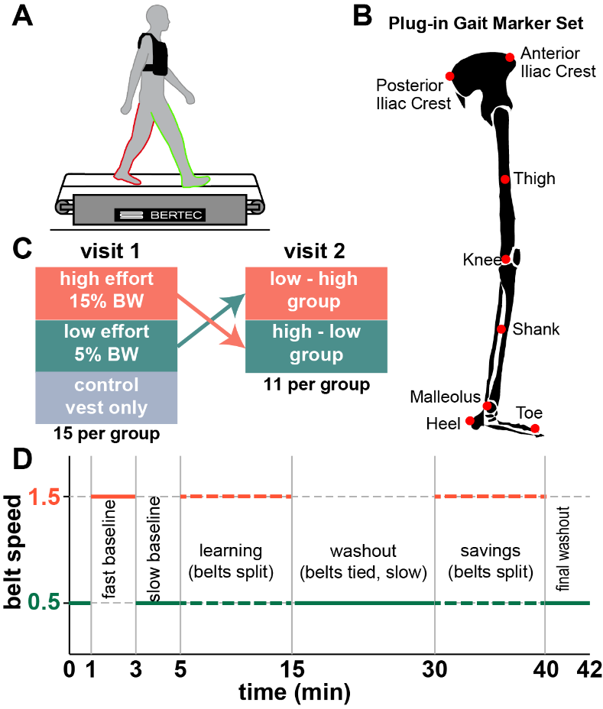
Figure 5: Split-belt methods
Methods for split belt walking task. A) split-belt walking shown with different belts for each leg. Handrails on either side are not shown. B) Plug-In Gait marker placement for the right side. Marker placement is mirrored on the left. C) Crossover study design. D) Protocol for baseline, learning, washout, and savings blocks.

Results
In our experiment, participants walked on a split belt treadmill in baseline, learning, washout, and savings blocks while wearing a weighted vest. The additional weight in the vest was determined by the participants’ effort condition with subjects in the control group wearing no additional weight, subjects in the low effort condition wearing 5% bodyweight, and subjects in the high effort condition wearing a vest with 15% bodyweight. For subjects who visited the lab twice and completed the task in both effort conditions, we observed strong order effects with multiple split-belt exposures leading to faster and faster learning. For this reason, our analysis is primarily on data from the first visit when subjects were naïve to the split-belt condition. Results from the second visit split-belt task are discussed at the end of this section.

Participants walked similarly during baseline at tied speeds.
Groups were demographically similar for height (p = 0.512), weight (p = 0.891), and leg length to height ratio (p = 0.741). All groups walked with symmetric step lengths (asymmetry equal to zero indicates symmetry) during fast baseline (t-test against hypothesis of zero mean: high effort p = 0.974; low effort p = 0.433; control p = 0.883) and during slow baseline (t-test against hypothesis of 0 mean: high effort p = 0.132; low effort p = 191; control p = 0.468).

Propulsion during baseline walking
We compared braking and propulsion forces during fast and slow baseline. Increased propulsive force has implicated in faster split-belt adaptation previously (Sombric and Torres-Oviedo 2020). We wanted to confirm that the weight added to differentiate effort conditions affected the braking and propulsive forces.
Force profiles for the vertical and anterior-posterior ground reaction forces, normalized to bodyweight, are included in figure ###. We compare the highest magnitude braking and push off forces as well as the propulsive impulse between groups in both baseline blocks. The highest magnitude braking forces differed between groups in the fast baseline walking condition (one way ANOVA p = 0.018) driven by a difference between the high and low effort groups (t-test p = 0.010) while none of the other pairwise comparisons revealed significant differences ( p_{high-control} = 0.186; p_{low-control} = 0.099). In the slow baseline walking condition, the magnitude of braking forces did not differ between groups (one way ANOVA: p = 0.130; t-tests: p_{high-low}= 0.080; p_{high-control} = 0.056; p_{low-control} = 0.667). Peak push off forces also differed between effort groups in the fast baseline walking condition (one way ANOVA: p = 0.001), though t-tests comparing each of the groups indicated no difference between peak push-off force between the low effort and control conditions: p_{high-low} < 0.001; p_{high-control} = 0.009; p_{low-control} = 0.576). The differences between groups are not apparent in the slow baseline walking where peak push-off forces were similar (one way ANOVA: p = 0.371; t-tests: p_{high-low}= 0.107; p_{high-control} = 0.487; p_{low-control} = 0.532). We also compared push-off impulse (integrated push-off force) between effort conditions. Impulse sums push-off force across the stance phase and thus may reveal increased propulsion that is not apparent in peak force measures. However, similar to peak push-off force, comparing impulse between effort groups showed significant differences between groups in the fast baseline condition and no differences in the slow baseline condition. Impulse differed between groups in fast baseline (one-way ANOVA: p = 0.014). The difference was driven by differences between the high and low effort groups because the other group pair comparisons (including the comparison of the high effort and control groups) were non-significant ( t-tests: p_{high-low} < 0.001; p_{high-control} = 0.053; p_{low-control} = 0.494). There were no differences in push-off impulse in the slow baseline walking condition (one way ANOVA: p = 0.430; t-tests: p_{high-low}= 0.244; p_{high-control} = 0.260; p_{low-control} = 0.986).

Single leg work during baseline walking
Peak propulsive force is not necessarily correlated with the work of braking and push-off contributed by each of the legs since single leg work incorporates vertical, anterior-posterior, and mediolateral ground reaction forces (ask Caelyn for citation ###). Though the anterior-posterior forces are smaller than the vertical ground reaction forces, the anterior-posterior center of mass (COM) velocity is high, so that the contribution to work is considerable. We wanted to understand if the added weight produced larger changes in single-leg work than in peak propulsive force. We assessed singe-leg work using the equations described by (Donelan et al. 2002).

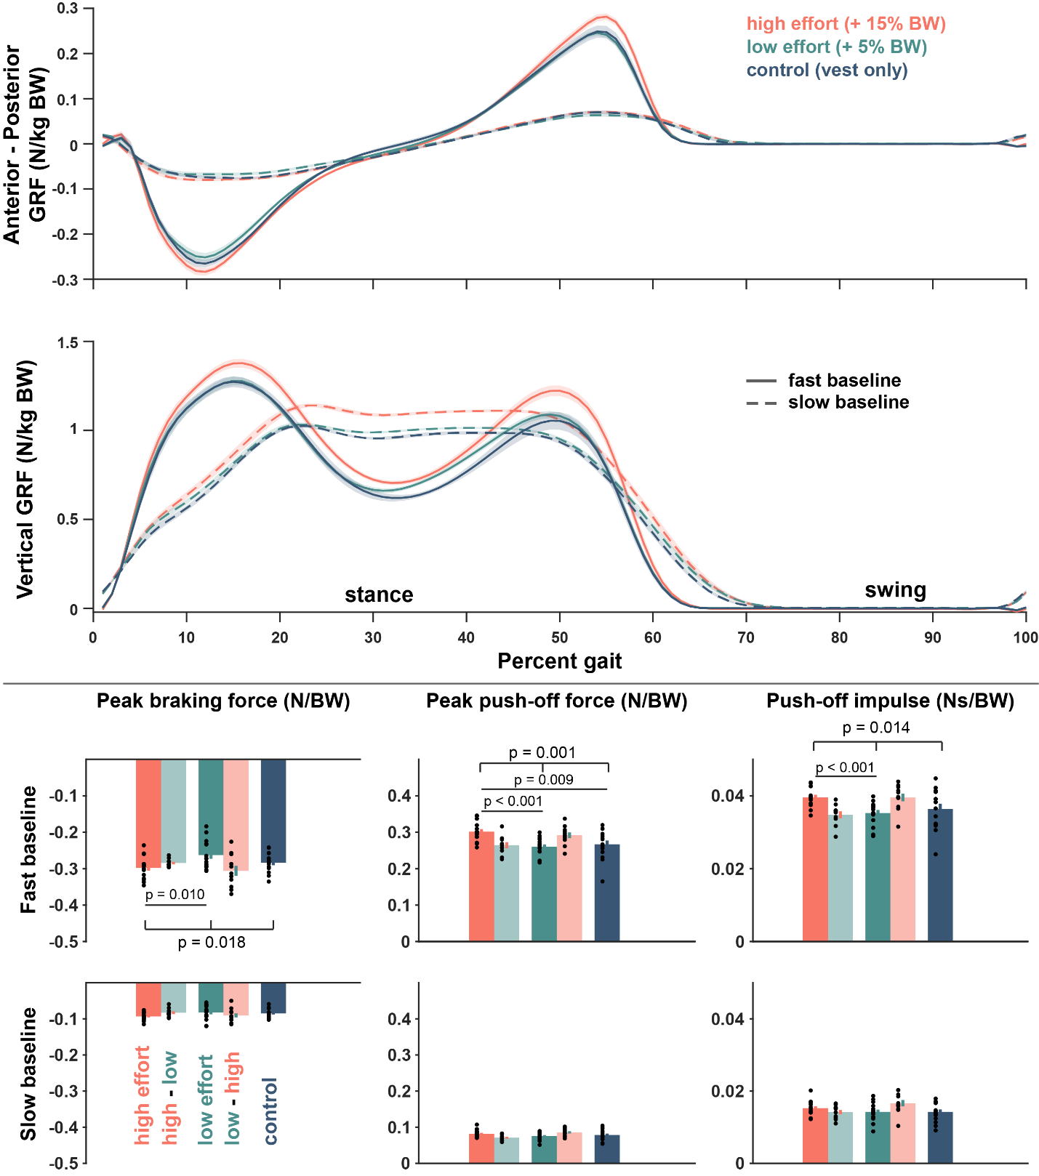

Step length variability during baseline walking
Prior to exposure to the split-belt perturbation, participants walked with the belts tied at the fast (1.5 m/s) and slow (0.5 m/s) speeds. We compared the variance of step lengths for the last 30 strides of the baseline block at each speed. At the fast baseline walking speed, variance was similar between the high, low, and control effort groups (One-way ANOVA: p = 0.283; Pairwise t-tests: p_{high-low}= 0.277; p_{high-control} = 0.724; p_{low-control} = 0.230). Variance increased at the slow baseline walking speed, but remained similar between groups (One-way ANOVA: p = 0.121; Pairwise t-tests: p_{high-low}= 0.240; p_{high-control} = 0.307; p_{low-control} = 0.073). We did not counterbalance the order of baseline walking and all slow baseline data was collected after the fast baseline data, so we cannot assess for an order effect. We did include an initial one-minute familiarization at the slow walking speed which preceded fast baseline. When we compare that familiarization with the slow baseline block following the fast baseline, we found no differences within groups (paired t-tests: p_{high} = 0.334, p_{low} = 0.448, p_{control} = 0.256).
For participants in the high-low and low-high groups, who completed both effort conditions, we compared step length variance during the last 20 strides of baseline in each effort condition and for each of the fast walking and the slow baseline blocks. Collectively, paired t-tests of variance indicated no differences between the low and high effort condition in either the fast (p = 0.634) or slow (p = 0.271) baseline blocks. When separated into the ordered group conditions (high-low and low-high), there were still no differences in the fast baseline walking (p_{high-low group}= 0.900; p_{low-high group}= 0.645). For the slow baseline, the variance was significantly higher in the low effort condition for participants in the low-high group (experienced the low effort condition first; p = 0.020). There was no change in variance for the high-low group (p = 0.179).
###
Step length variance compared between high and low effort conditions for participants that completed two visits (one in each of the two effort conditions)

Step length asymmetry and learning during initial adaptation.
Step length asymmetry curves over the course of the learning block are included in figure 6. Initial step length asymmetry is negative for all groups indicating that participants responded to the split-belt perturbation by taking longer steps on the slow leg. Over time, all groups adjusted their relative step lengths to be more similar, although the slight bias toward longer steps on the slow leg persisted for the duration of the 10-minute learning block. Qualitatively, the curves representing the high effort and control groups proceed toward symmetry more quickly than the low effort group. Towards the end of adaptation, all groups have similar steady state asymmetries.

Binned learning phases
To match common split-belt analyses, we compared blocks of trials representing different phases of the learning process (initial: strides 1-5, early: strides 6-30, late: strides 31-200, and plateau: final 30 strides) using one-way ANOVA. We found no difference between groups at any phase of the learning process. (ANOVA on initial bin: p = 0.464; early bin: p = 0.110; late bin: p = 0. 298; and plateau bin: p = 0.361), see figure 6b. Pairwise comparisons of the high effort, low effort, and control groups yielded no significant differences, see table.
Pair compared | Initial | Early | Late | Plateau
High v Low | p = 0.332 | p = 0.070 | p = 0.127 | p = 0.219
High v Control | p = 0.882 | p = 0.841 | p = 0.438 | p = 0.163
Low v Control | p = 0.296 | p = 0.102 | p = 0.433 | p = 0.726
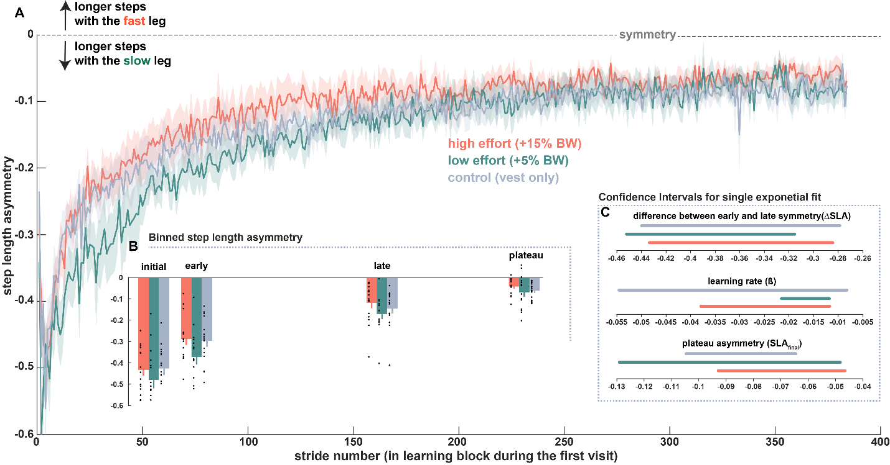
Figure 6: Step length asymmetry during split-belt learning
Step length asymmetry A) step length asymmetry for strides during the learning block. B) binned step length asymmetry for initial, early, late, and plateau. C) confidence intervals for exponential fit parameters showing how the intervals overlap.

State space learning fit
Each participant’s SLA curve was fitted with a state space model with remembering factor (α) and learning rate (β) parameters. Remembering factor, representing what proportion of the asymmetry from the previous stride is carried forward into the next, was similar between groups (mean and standard error are included in Table ###). Pairwise comparisons also showed no differences between the remembering factor between any pair of the three groups (p_{high-low}= 0.359; p_{high-control} = 0.664; p_{low-control} = 0.638). Learning rate captures sensitivity to asymmetry or what proportion of the asymmetry the participant responds to in order to mitigate asymmetry on the subsequent step. A high learning rate indicates a high sensitivity to error and will result in rapid initial progress toward symmetry. In contrast a lower learning rate will progress more slowly toward symmetry. Learning rate was similar between groups (mean and standard error are included in Table ###). Pairwise comparisons also showed no differences between learning rate between any pair of the three groups (p_{high-low}= 0.139; p_{high-control} = 0.835; p_{low-control} = 0.477).
State space fit parameter | High effort | Low effort | Control effort | One-way ANOVA
Remembering factor (α) | 0.97 ± 0.005 | 0.98 ± 0.005 | 0.97 ± 0.005 | p = 0.657
Learning rate ($β$) | 0.01 ± 0.001 | 0.01 ± 0.001 | 0.01 ± 0.002 | p = 0.554
Initial asymmetry (${\hat{y}}_{1}$) | -0.43 ± 0.028 | -0.48 ± 0.039 | -0.43 ± 0.031 | p = 0.463

State space learning fits excluding the first 5 strides (where people are highly variable, sometimes tripping / cross stepping)
Pairwise comparisons also showed no differences between the remembering factor between any pair of the three groups (p_{high-low}= 0. 417; p_{high-control} = 0. 998; p_{low-control} = 0. 439). Learning rate was similar between groups (mean and standard error are included in Table ###). Pairwise comparisons also showed no differences between learning rate between any pair of the three groups (p_{high-low}= 0. 071; p_{high-control} = 0. 908; p_{low-control} = 0. 127).
State space fit parameter | High effort | Low effort | Control effort | One-way ANOVA
Remembering factor (α) | 0.99 ± 0.003 | 0.99 ± 0.003 | 0.99 ± 0.003 | p = 0.661
Learning rate ($β$) | 0.01 ± 0.002 | 0.01 ± 0.001 | 0.01 ± 0.002 | p = 0.223
Initial asymmetry (${\hat{y}}_{1}$) | -0.417 ± 0.036 | -0.46 ± 0.036 | -0.41 ± 0.029 | p = 0.571

Exponential learning fits
Step length asymmetry curves were descriptively modeled for each participant using a single exponential function. When fit across all strides of the first learning block, single exponential fits showed no differences in the exponential coefficient (change in symmetry, $∆SLA$), exponential learning rate (β), or the exponential constant (final asymmetry, ${SLA}_{final}$) for step length asymmetry. Means and standard error for the exponential fit parameters are included in Table ###. Fit parameters were compared between groups using one-way ANOVAs. Pairwise comparisons also showed no differences between exponential coefficient (p_{high-low}= 0.338; p_{high-control} = 0. 780; p_{low-control} = 0. 332), exponential learning rate (p_{high-low}= 0. 316; p_{high-control} = 0. 395; p_{low-control} = 0.107), or exponential constant (p_{high-low}= 0. 322; p_{high-control} = 0. 791; p_{low-control} = 0. 330).
Exponential fit parameter | High effort | Low effort | Control effort | One-way ANOVA
Coefficient ($∆SLA$) | -2.07 ± 1.657 | -0.45 ± 0.040 | 2.91 ± 2.490 | p = 0.597
Learning rate ($β$) | 0.03 ± 0.007 | 0.03 ± 0.005 | 0.05 ± 0.011 | p = 0.222
Constant (${SLA}_{final}$) | 1.59 ± 1.653 | -0.07 ± 0.023 | 2.39 ± 2.487 | p = 0.591

Exponential learning fits excluding the first 5 strides (where people are highly variable, sometimes tripping or cross stepping)
Means and standard error for the exponential fit parameters are included in Table ###. Fit parameters were compared between groups using one-way ANOVAs. Pairwise comparisons also showed no differences between exponential coefficient (p_{high-low}= 0.735; p_{high-control} = 0.301; p_{low-control} = 0.453), exponential learning rate (p_{high-low}= 0. 065; p_{high-control} = 0. 349; p_{low-control} = 0. 104), or exponential constant (p_{high-low}= 0. 244; p_{high-control} = 0. 601; p_{low-control} = 0. 265).
Exponential fit parameter | High effort | Low effort | Control effort | One-way ANOVA
Coefficient ($∆SLA$) | -0.37 ± 0.037 | -0.38 ± 0.03 | -0.43 ± 0.041 | p = 0.537
Learning rate ($β$) | 0.036 ± 0.009 | 0.02 ± 0.002 | 0.06 ± 0.026 | p = 0.159
Constant (${SLA}_{final}$) | -0.05 ± 0.008 | -0.07 ± 0.018 | -0.03 ± 0.031 | p = 0. 403

Exponential fit of normalized step length asymmetry
Normalizing step length asymmetry may help reduce the differences between subjects especially in terms of the constant offset and the coefficient scaling. For these fits, individual subject’s asymmetry curves are normalized by division to the maximum of their smoothed step length asymmetry curve (using MATLAB smooth, and smoothing over 10 strides).
Means and standard error for the exponential fit parameters are included in Table ###. Fit parameters were compared between groups using one-way ANOVAs. Pairwise comparisons also showed no differences between exponential coefficient (p_{high-low}= 0. 504; p_{high-control} = 0. 456; p_{low-control} = 0. 267), exponential learning rate (p_{high-low}= 0.110; p_{high-control} = 0.863; p_{low-control} = 0. 203), or exponential constant (p_{high-low}= 0. 558; p_{high-control} = 0. 218; p_{low-control} = 0. 164).
Exponential fit parameter | High effort | Low effort | Control effort | One-way ANOVA
Coefficient ($∆SLA$) | -0.82 ± 0.045 | -0.78 ± 0.044 | -0.91 ± 0.104 | p = 0.429
Learning rate ($β$) | 0.03 ± 0.008 | 0.02 ± 0.003 | 0.04 ± 0.013 | p = 0.354
Constant (${SLA}_{final}$) | -0.10 ± 0.018 | -0.13 ± 0.036 | 0.03 ± 0.099 | p = 0.190

Model fit bootstrapping
To improve our confidence in these results, we bootstrapped the state space and exponential fit data in two ways. In the first bootstrapping protocol, we resampled individual’s SLA curves and fit the group average curves using the state space and exponential models. In the second protocol, individuals’ state space and exponential fit parameters were resampled. We followed each of these two protocols for each of the two models (2 x 2) and repeated sampling 10000 times, generating approximate population distributions for each of the model parameters.
Both bootstrapping protocols result in similar distributions between the effort conditions for both models. In all four cases, 95% confidence intervals for the bootstrap data overlapped for all parameters.
State Space Fit Bootstrap
Procedure 1: resample SLA curves | High effort CI | Low effort CI | Control effort CI
Remembering factor (α) | [0.991 0.997] | [0.994 0.996] | [0.993 0.998]
Learning rate ($β$) | [0.002 0.010] | [0.003 0.006] | [0.002 0.007]
Initial value (${\hat{y}}_{1}$) | [-0.4733 -0.370] | [-0.555 -0.415] | [-0.487 -0.361]
Procedure 2: resample fit parameters | High effort CI | Low effort CI | Control effort CI
Remembering factor (α) | [0.965 0.987] | [0.962 0.985] | [0.96246 0.98726]
Learning rate ($β$) | [0.008 0.013] | [0.008 0.011] | [0.006 0.009]
Initial value (${\hat{y}}_{1}$) | [-0.509 -0.368] | [-0.567 -0.372] | [-0.537 -0.405]
Table #: bootstrapped state space fit parameters

Exponential Fit Bootstrap
Procedure 1: resample SLA curves | High effort CI | Low effort CI | Control effort CI
Coefficient ($∆SLA$) | [-0.423 -0.276] | [-0.448 -0.326] | [-0.372 -0.245]
Learning rate ($β$) | [0.0115 0.037] | [0.011 0.019] | [0.007 0.0343]
Constant (${SLA}_{final}$) | [-0.093 -0.050] | [-0.119 -0.045] | [-0.117 -0.065]
Procedure 2: resample fit parameters | High effort CI | Low effort CI | Control effort CI
Coefficient ($∆SLA$) | [-0.512 -0.333] | [-0.519 -0.320] | [-0.562 -0.323]
Learning rate ($β$) | [0.021 0.048] | [0.017 0.040] | [0.020 0.070]
Constant (${SLA}_{final}$) | [-0.105 -0.003] | [-0.138 -0.032] | [-0.133 -0.072]
Table 2: bootstrapped exponential fit parameters
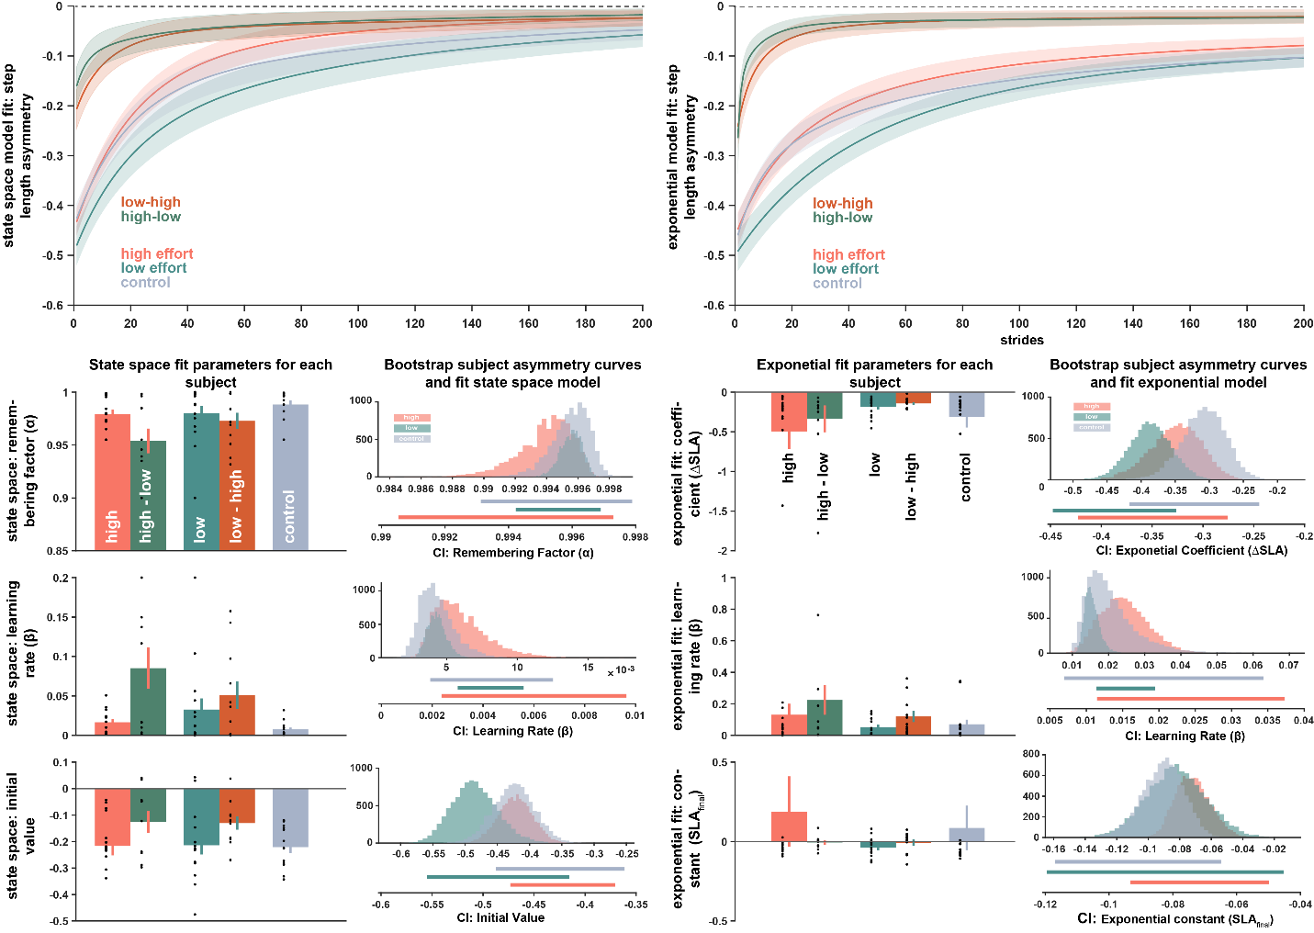
State space (left) and Exponential (right) model asymmetry curves, fit parameters, and bootstrap fit parameters

Strides to plateau
Learning rate can be compared without imposing a fitting assumption by comparing the number of strides to the asymmetry plateau (Malone and Bastian 2010). For each subject, we smoothed the asymmetry curve in moving average with three strides per bin and then defined the plateau range as the average asymmetry of the final 30 strides of the block plus or minus the standard deviation of the asymmetry of those strides. The first stride to plateau was defined as the first stride number followed by five consecutive strides that fell within the plateau range. The strides to plateau metrics following are reported as mean ± standard error, and the large standard errors indicate that the metric is extremely variable.
For initial learning, the first stride to the plateau was 172.6 ± 35.35 strides for the high effort condition, 182.6 ± 21.53 strides for the low effort condition, and 156.5 ± 31.15 strides for the control condition. Compared via ANOVA, (as in the Malone and Bastian 2010 paper), these values are similar with p = 0.825. Pairwise comparisons were also nonsignificant: (p_{high-low}= 0.811; p_{high-control} = 0.736; p_{low-control} = 0.497).
In relearning, the first stride to the plateau occurred sooner for all groups: 45.3 ± 10.09 strides for the high effort condition, 68.4 ± 13.45 strides for the low effort condition, and 91.1± 35.68 strides for the control condition, but did not differ between groups, p = 0.371 or between one another in pairwise comparisons: (p_{high-low}= 0.180; p_{high-control} = 0.226; p_{low-control} = 0.556).
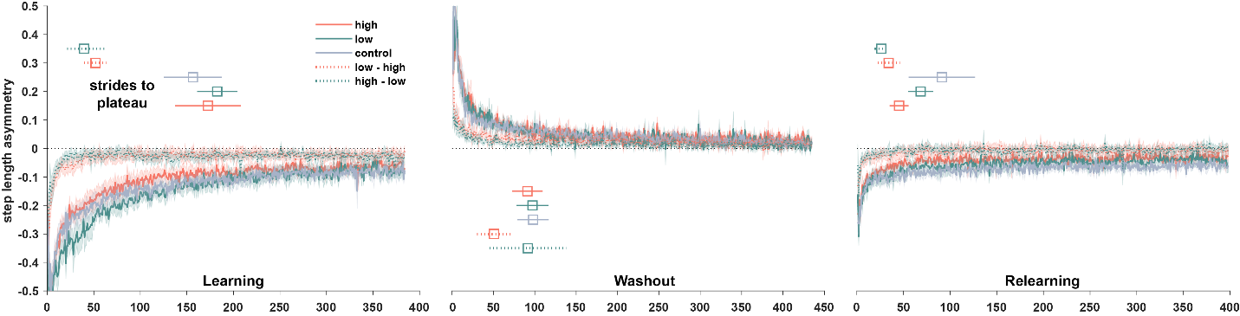
On the second visit, the high-low and low-high groups preserved the shorter time to symmetry that was observed in relearning. The high-low group had 39.5 ± 17.37 strides to symmetry and the low-high group had 51.8± 12.13 strides to symmetry during learning (p = 0.574). During relearning on the second visit, there was little improvement from the earlier learning block with the high-low group achieving symmetry in 26.2 ± 6.67 strides and the low-high group achieving symmetry in 34.1 ± 11.95 strides (p = 0.585).

Step width and stability
Taking wider steps increases the base of support and is one strategy for countering instability. Despite this, previous studies have not observed changes in step width associated with split-belt walking (Darter et al. 2018). Given the addition of weight to the upper body in the high effort conditions, we compared step width values and step width variance between effort groups to assess the effect of added weight on stability.
Step widths were unaffected by effort condition in fast baseline (p = 0.567). In slow baseline, step widths differed between groups (p = 0.037), with the difference being driven by the pairwise comparison between the low effort and control groups (p = 0.013), while the high to low and high to control comparisons were nonsignificant (p = 0.332 and p = 0.298 respectively).
Step widths differed between experimental blocks (wider steps during slow baseline than during fast baseline; p = ###) and between fast and slow legs (wider steps on the fast leg in learning: p= ###; and in relearning: p = ####). During split-belt learning, both fast and slow leg step widths were narrower than slow baseline (fast leg < slow baseline: p = ####; and slow leg < slow baseline: p = ###) and the difference persisted during relearning (fast leg < slow baseline: p = ####; and slow leg < slow baseline: p = ###).
Step width variability was significantly higher during fast baseline walking for the high effort group on the first visit (paired t-test between slow and fast baseline: p_{high}= 0.003), but not for the low effort or control groups (p_{low} = 0.199; p_{control} = 0.233). During the second visit, the low-high group showed no difference in step width variance between high and low baseline (p_{low-high group}= 0.330) while the high-low group was more variable during fast baseline (p_{high-low group}= 0.022).
In split-belt blocks, fast leg step widths were not different between effort conditions (ANOVA, p = ###) and neither were slow leg step widths (ANOVA, p = ###).
In learning, step width variance did not differ between effort conditions for the fast leg (ANOVA on step width variance: p = 0.540) or for the slow leg (ANOVA on step width variance: p = 0.369). Similarly, step width variance during washout did not differ between effort groups (fast leg: p = 0.520; slow leg: p = 0.379), nor during relearning (fast leg: p = 0.309; slow leg: p = 0.245).
For participants that participated in both high and low effort conditions, compared step width variance during the last 20 strides of baseline in each effort condition. Paired t-tests of variance indicated no differences between the low and high effort condition in either the fast (p = 0.634) or slow (p = 0.271) baseline blocks. When separated into the ordered group conditions (high-low and low-high), there were still no differences in the fast baseline walking (p_{high-low group}= 0.900; p_{low-high group}= 0.645). For the slow baseline, the variance was significantly higher in the low effort condition for participants in the low-high group (experienced the low effort condition first; p = 0.020). There was no change in variance for the high-low group (p = 0.179).

Linear mixed effects modeling
We generated a linear mixed effects model (LMER; equation 6) for step length asymmetry based on fixed effects of effort condition and log-transformed stride number. We included a random effect for each subject. As with the exponential fits, we ran the model for the whole adaptation and for a subset consisting of the first 200 strides. As there was no difference in the results, we report the model coefficients for the model all strides. Recall that, since step length asymmetry curves are negative, increasing SLA corresponds to increasing symmetry.
 | $$SLA \sim effort condition * log(stride number) + (1|subj)$$ | Equation 6
Linear mixed effects models including data only for the first exposure
Unweighted: When fitting for only the initial exposure, we generated linear mixed effects models using either a factor for effort condition or a continuous variable for normalized added mass. Since effort condition is included as a factor, coefficients reported are relative to a reference. In this case, the reference is the control effort condition.
Predictors of SLA (effort condition) | Coefficient value | Confidence intervals | p value
High effort (vs control) | 1.727e-02 | -0.031214587 0.065756539 | 0.480
Low effort (vs control) | -1.337e-01 | -0.182998178 -0.084329767 | 1.74e-06 ***
Log transform of stride | 6.933e-02 | 0.067708664 0.070951062 | < 2e-16 ***
Interaction: high effort condition and stride number | 6.172e-04 | -0.001669218 0.002903628 | 0.597
Interaction: low effort condition and stride number | 2.213e-02 | 0.019811660 0.024441116 | < 2e-16 ***
I repeated this analysis using normalized added mass as a continuous variable rather than effort condition as a factor.
Predictors of SLA (added mass) | Coefficient value | Confidence intervals | p value
Normalized added mass | 1.221e-01 | -0.01527410 0.2595495923 | 0.0817
Log transform of stride | 7.771e-02 | 0.07639290 0.0790250655 | <2e-16 ***
Interaction: normalized added mass and stride number | -7.133e-03 | -0.01359639 -0.0006696975 | 0.0305 *

Weighted: Using a linear model to select weights for each point in the LMER, we generated weighted linear mixed effects model using either a factor for effort condition or a continuous variable for normalized added mass
Weighted LMER: Predictors of SLA (effort condition) | Coefficient value | Confidence intervals | p value
High effort (vs control) | 3.326e-02 | 0.03325925 0.033322803 | 0.1457
Low effort (vs control) | -9.959e-02 | -0.09958541 -0.099515780 | 6.66e-05 ***
Log transform of stride | 6.306e-02 | 0.06305613 0.063058481 | < 2e-16 ***
Interaction: high effort condition and stride number | -2.447e-03 | -0.00244743 -0.002443421 | 0.0735
Interaction: low effort condition and stride number | 1.589e-02 | 0.01589073 0.015894888 | < 2e-16 ***
Xlkdahjg
Weighted LMER: Predictors of SLA (added mass) | Coefficient value | Confidence intervals | p value
Normalized added mass | 1.835e-01 | 0.18345788 0.18361693 non-monotonic profile | 0.00524 **
Log transform of stride | 6.972e-02 | 0.06972337 0.06972520 non-monotonic profile | < 2e-16 ***
Interaction: normalized added mass and stride number | -1.873e-02 | -0.01873390 -0.01872300 non monotonic profiel | 2.43e-06 ***

The linear mixed effect model results indicated a difference between the low effort and high effort conditions. Since effort condition is included as a factor, coefficients reported are relative to a reference. In this case, the reference is the high effort condition. Thus, the negative coefficient for the low effort condition (coefficient: -0.118; CI: [-0.184, -0.051]; p = 8.55e-4) indicates a decrease in the expected step length asymmetry based on being in the low effort condition. The fixed effect coefficient for the control condition is non-significant (see table 3 for complete list of coefficient values, confidence intervals, and p values). Because of the learning process, the fixed effect for stride number is strongly predictive, corresponding to increasing symmetry over the course of adaptation.
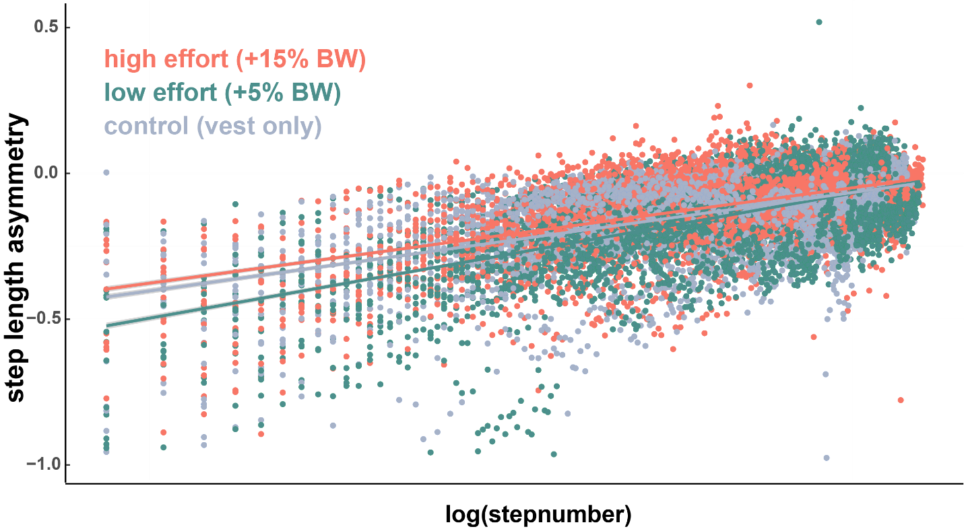
SLA versus log(*stride* number) shows how early strides have an outsized effect on the slopes fit for each effort condition.

Significance in the interaction terms (between low effort condition and stride number and between control condition and stride number) indicated that the relationship between stride number and step length asymmetry changed between the effort conditions. This interaction was significant even in the case of the control condition, where the fixed effect of effort condition itself was not a significant predictor. Both interactions are positive. For the interaction between the low effort condition and stride number, this means that as stride number increases, the negative effect of the low effort condition is attenuated. This is consistent with what we can see of the low effort group in figure 6. Visually, during the first 100 strides, the low effort group has more negative asymmetry (a result that is captured in the negative coefficient value for the low effort group in the LMER); however, beginning around 150 strides, asymmetry in the low effort group closely resembles that of the other two groups, suggesting an attenuated effect of the effort condition later in the adaptation period (captured in the positive interaction term between low effort and stride number). For the interaction between the control effort condition and stride number indicates that as stride number increases, symmetry increases more in the control effort condition.
Predictors of SLA (effort condition) | Coefficient value | Confidence intervals | p value
Low effort (vs high effort) | -0.118 | [-0.184, -0.051] | p = 8.55e-4
Control effort (vs high effort) | 0.020 | [-0.046, 0.087] | p = 0.549
Log transform of stride | 0.086 | [0.083, 0.089] | P < 2e-16
Interaction: low effort condition and stride number | 0.014 | [0.010, 0.019] | p = 3.25e-10
Interaction: control effort condition and stride number | 0.010 | [-0.145, -0.006] | p = 8.53e-6
Table 3: Split-belt LMER on learning block with fixed effect of effort condition
We generated a second linear mixed effects model which replaced the effort condition factor with a continuous fixed effect of normalized added mass (added mass / bodyweight). Coefficient values, confidence intervals, and p values are included in table 4. Because the added weight differentiated groups, this model can indicate differences related to added weight without a comparison to a reference group. This model showed no fixed effect of added mass. As before, there was a strong effect of stride number and a significant interaction between added mass and stride number suggested that the symmetry increases further at high stride numbers for higher added mass.
Predictors of SLA (added mass) | Coefficient value | Confidence intervals | p value
Normalized added mass | -0.001 | [-0.192, 0.189] | p = 0.989
Log transform of stride | 0.084 | [0.082, 0.087] | P < 2e-16
Interaction: normalized added mass and stride number | 0.002 | [0.012, 0.037] | p = 1.54e-4
Table 4: Split-belt LMER on learning block with fixed effect of added mass
Linear mixed effects models including data only for all exposures
Unweighted based on effort condition factor: Introduce a new pair of LMER models that include all of the split belt data (all four exposures) and includes factors for exposure and for exposure within the day.
 | $$SLA \sim effort condition * log(stride number) + exposure\# * split-belt block \# + (1|subj)$$ | Equation
This incorporates all of the learning related data and might be able to indicate more lasting differences between the groups. This method still suffers from the heavy bias toward early trial differences that is associated with the log transform.
Unweighted all exposures: predictors of SLA (effort condition) | Coefficient value | Confidence intervals | p value
High effort (vs control) | 7.711e-02 | 0.045095205 0.109118157 | 1.42e-05 ***
Low effort (vs control) | 2.796e-02 | -0.004073649 0.059985529 | 0.0872
Log transform of stride | 4.464e-02 | 0.043495098 0.045790148 | < 2e-16 ***
Split-belt exposure | 5.074e-02 | 0.048934042 0.052543539 | < 2e-16 ***
Learning or relearning | 4.901e-02 | 0.046311775 0.0517162 | < 2e-16 ***
Interaction: high effort condition and stride number | -1.122e-02 | -0.012664149 -0.009774920 | < 2e-16 ***
Interaction: low effort condition and stride number | -4.074e-03 | -0.005532698 -0.002615367 | 4.41e-08 ***
Interaction: overall exposure and learning vs relearning | -1.417e-02 | -0.015296319 -0.013047139 | < 2e-16 ***
Using residuals from a linear model, I determined weights and refit the LMER.
Weighted all exposures: predictors of SLA (effort condition) | Coefficient value | Confidence intervals | p value
High effort (vs control) | 9.958e-02 | 0.099576110 0.099604189 | 2.98e-08 ***
Low effort (vs control) | 4.957e-02 | 0.049571960 0.049601887 | 0.00222 **
Log transform of stride | 3.774e-02 | 0.037738540 0.037739738 | < 2e-16 ***
Split-belt exposure | 4.024e-02 | 0.040242401 0.040243853 | < 2e-16 ***
Learning or relearning | 3.677e-02 | 0.036771980 0.036774275 | < 2e-16 ***
Interaction: high effort condition and stride number | -1.462e-02 | -0.014622252 -0.014620508 | < 2e-16 ***
Interaction: low effort condition and stride number | -7.216e-03 | -0.007215734 -0.007213834 | 8.09e-16 ***
Interaction: overall exposure and learning vs relearning | -1.002e-02 | -0.010024483 -0.010023492 | < 2e-16 ***
Considering the unweighted model, when all the data is included the results differ from the results for the first exposure fit. Specifically, the control group, which was indistinguishable from the high effort group during the first learning block, is now significantly different from the high effort group and indistinguishable from the low effort group.

Effort conditions had similar aftereffects during washout.
After adapting to the split-belt perturbation in the initial learning block, participants walked for 15 minutes with the belts tied at the slow speed to washout the adaptation (Figure 7a). Early in washout, participants experienced aftereffects from the split-belt walking where the direction of asymmetry was reversed and steps on the fast leg were longer. Binned de-adaptation phases indicated no difference in this process between effort conditions. (ANOVA on initial bin: p = 0.699; early bin: p = 0.740; late bin: p = 0. 899; and plateau bin: p = 0.560).
The decay of aftereffects was also compared using exponential fits: based on one-way ANOVA, there were no differences in coefficient, $∆SLA$ (p = 0.370), constant, ${SLA}_{final}$ (p = 0.975),or learning rate β (p = 0.548).
We checked symmetry at the end of the washout block to confirm that aftereffects had faded entirely. In the low and control effort conditions, strides during the plateau period at the end of washout were symmetric (t-test against zero mean: low effort p = 0.383; control p = 0.144). Results for the high effort group indicated a lingering bias toward positive asymmetry (p = 0.006) which was also significantly different from symmetry measured during slow baseline walking (paired t-test: p = 0.044). However, the effect size is small, with the step length asymmetry during the washout plateau at less than 5% the initial aftereffect asymmetry (SLA = 0.027 ± 0.008 (mean ± standard error)). Furthermore, there was no difference in step length asymmetry between groups at the plateau of washout which was tested as part of the binned de-adaptation phases (figure 7b).

Effort conditions showed similar savings during relearning after washout.
Qualitatively, based on average step length asymmetry curves, participants relearned the adaptation more rapidly when re-exposed to the split-belt following tied washout (figure 7c). Since we determined the parameters of the exponential fit for each subject individually, we used paired t-tests to compare the fit parameters for learning and savings within each effort condition. Though we anticipated faster learning rate parameters between learning and savings for all groups, the difference was only significant for the low effort group (see table 5). Because of the compelling visual evidence, these results need to be further verified.
 | High effort | Low effort | control
Coefficient, $∆SLA$ | p = 0.679 | p = 0.011* | p = 0.001**
Learning rate, $β$ | p = 0.152 | p = 0.049* | p = 0.155
Constant, ${SLA}_{final}$ | p = 0.297 | p = 2.32e-05*** | p = 0.270
Table 5: Split-belt exponential fit parameters compared between learning and relearning (paired t-test).
The process of relearning did not differ between the effort conditions.
Binned relearning phases showed no difference between relearning in initial, early, late, or plateau trial bins (ANOVA on initial bin: p = 0.987; early bin: p = 0.579; late bin: p = 0. 218; and plateau bin: p = 0.216).
Single exponential fits showed no differences for step length asymmetry in savings. Fit parameters were compared between groups using one-way ANOVAs (coefficient, $∆SLA$: p = 0.235; constant, ${SLA}_{final}$: p = 0.336; learning rate β: p = 0.643).
In a linear mixed effects model with fixed effects of effort condition and the log transform of stride number, only stride number was a significant predictor of asymmetry during savings.
Predictors of SLA (effort condition) | Coefficient value | Confidence intervals | p value
Low effort (vs high effort) | -0.030 | [-0.071, -0.011] | p = 0.146
Control effort (vs high effort) | -0.021 | [-0.061, 0.019] | p = 0.306
Log transform of stride | 0.030 | [0.028, 0.032] | P < 2e-16
Interaction: low effort condition and stride number | -0.018 | [-0.001, 0.032] | p = 0.226
Interaction: control effort condition and stride number | -0.027 | [-0.006, 0.000] | p = 0.061
Table 6: Split-belt LMER on savings block with fixed effect of effort condition.
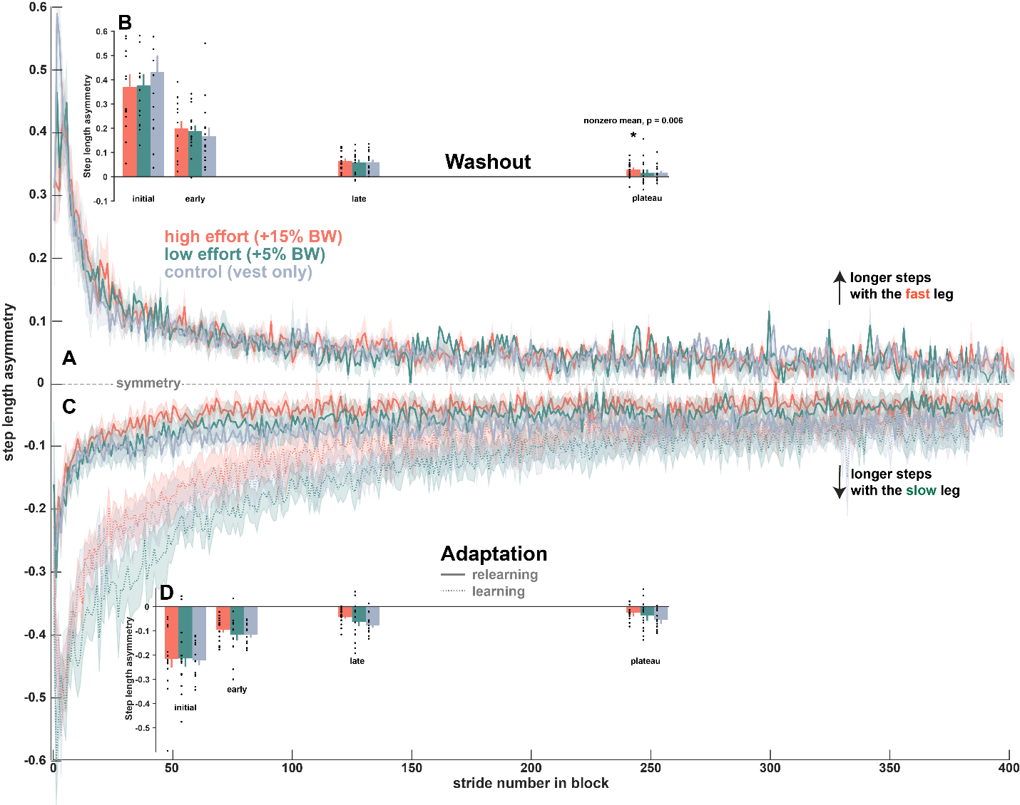
Figure 7: Split-belt washout and savings
Washout and relearning. A) washout curves showing the gradual decay of step length asymmetry aftereffects for all groups. B) binned de-adaptation phases showing similar step length asymmetry during all phases of washout. The nonzero washout plateau symmetry for the high effort condition is noted, but the high effort condition asymmetry does not differ from the other two groups. C) step length asymmetry during relearning (initial learning included as a dashed line for comparison), showing initial rapid progress toward symmetry for all groups. D) binned re-adaptation phases for savings.

There was no difference in learning, washout, or relearning when participants switched effort conditions on a second visit.
A subset of participants in the high and low effort conditions for the first visit returned for a second visit and repeated the task in the opposite effort condition. This provided an opportunity to gauge differences in long term savings and motor memory consolidation between participants who experienced high or low effort conditions when initially exposed to the perturbation. We focus on the learning block of the second session where participants are exposed to split-belt perturbation for the third time and are relearning after a minimum delay of 24 hours. Notably, these participants are now in the opposite effort condition of their first visit (high $→$low and low$→$high).
Visually, there is some difference in early adaptation to the split-belt, before 50 strides in figure 8. The teal line indicates participants are wearing 5% body weight in the vest, but they initially learned in the high effort condition. This visual difference is not confirmed in the statistical analyses.
Binned learning phases showed no difference between the high and low conditions on the second visit (t-test for comparing high and low effort conditions: initial p = 0.390; early p = 0.411; late p = 0.901; plateau p = 0.752; Figure 8b). The same was true for binned washout (t-test for comparing high and low effort conditions: initial p = 0.284; early p = 0.423; late p = 0.193; plateau p = 0.402) and binned savings (t-test for comparing high and low effort conditions: initial p = 0.922; early p = 0.768; late p = 0.943; plateau p = 0.954) during the second visit.
Exponential fits confirmed the similarity between the two effort conditions. All fit parameters were comparable for learning (t-test between groups: coefficient, $∆SLA$: p = 0.240; constant, ${SLA}_{final}$: p = 0.191; learning rate β: p = 0.646), washout (t-test between groups: coefficient, $∆SLA$: p = 0.303; constant, ${SLA}_{final}$: p = 0.668; learning rate β: p = 0.709), and savings (t-test between groups: coefficient, $∆SLA$: p = 0.735; constant, ${SLA}_{final}$: p = 0.913; learning rate β: p = 0.695).
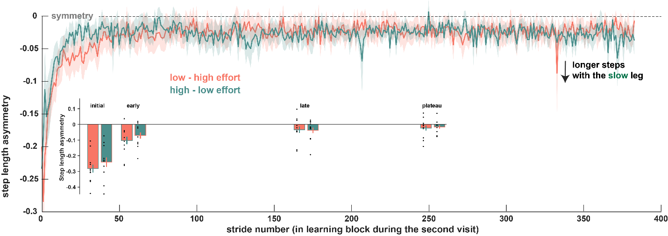
Figure 8: Step length asymmetry during second visit.
Step length asymmetry during learning on a second visit and binned learning phases to compare the two groups.

*Discussion

Summary
Participants adapted their gait to walk on a split-belt treadmill in one of three effort conditions, carrying 15% or 5% of their bodyweight in a vest for the two experimental conditions and wearing the vest only in the control condition. The experimental task included 10-minute adaptation and re-adaptation blocks during which participants walked on treadmill belts at a 3:1 speed ratio. The two blocks were separated by a 15-minute washout period. During initial adaptation, LMER analysis showed slower adaptation in the low effort group than in high effort group, especially early in adaptation period. There were no differences in the extent of adaptation between groups. The control condition learns fast, at a rate similar to that of the high effort group. During washout and savings, all effort conditions show similar aftereffects and faster relearning. A subset of participants returned for crossover study and completed the task a second time in the opposite effort condition (first and second visits were high – low or low-high). Relearning the split-belt perturbation during the second visit (third exposure) demonstrated long lasting savings for both groups and did not differ between groups. So, while the data suggests a difference between low and high effort conditions in initial learning, we are still trying to interpret this finding while accounting for the control group and the strong savings effects in all conditions.

